**Logging Using SLF4J**

**1.Logging error messages and warning levels**

**LoggingExample.java**

import org.slf4j.Logger;

import org.slf4j.LoggerFactory;

public class LoggingExample {

private static final Logger logger = LoggerFactory.getLogger(LoggingExample.class);

public static void main(String[] args) {

logger.error("This is an error message");

logger.warn("This is a warning message");

}

}

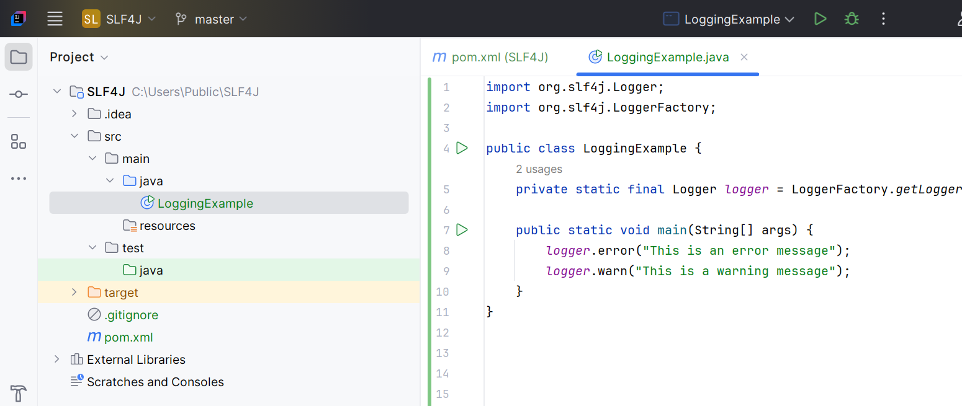

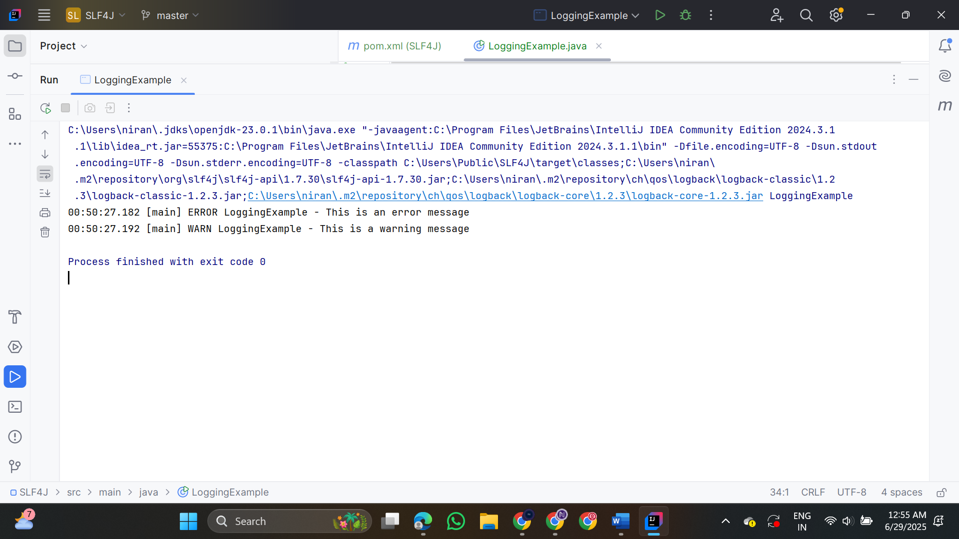

**2. Parameterized Logging**

**LoggingParameterizedExample.java**

import org.slf4j.Logger;  
import org.slf4j.LoggerFactory;  
  
public class LoggingParameterizedExample {

private static final Logger logger = LoggerFactory.getLogger(LoggingParameterizedExample.class);  
  
 public static void main(String[] args) {  
 String username = "ruba";  
 int items = 5;  
 double price = 12.99;  
  
 logger.info("User {} added {} items to cart. Total price = {}", username, items, price);  
  
 int errorCode = 404;  
 String page = "/products/unknown";  
  
 logger.error("Error code {} occurred while accessing {}", errorCode, page);  
 }  
}

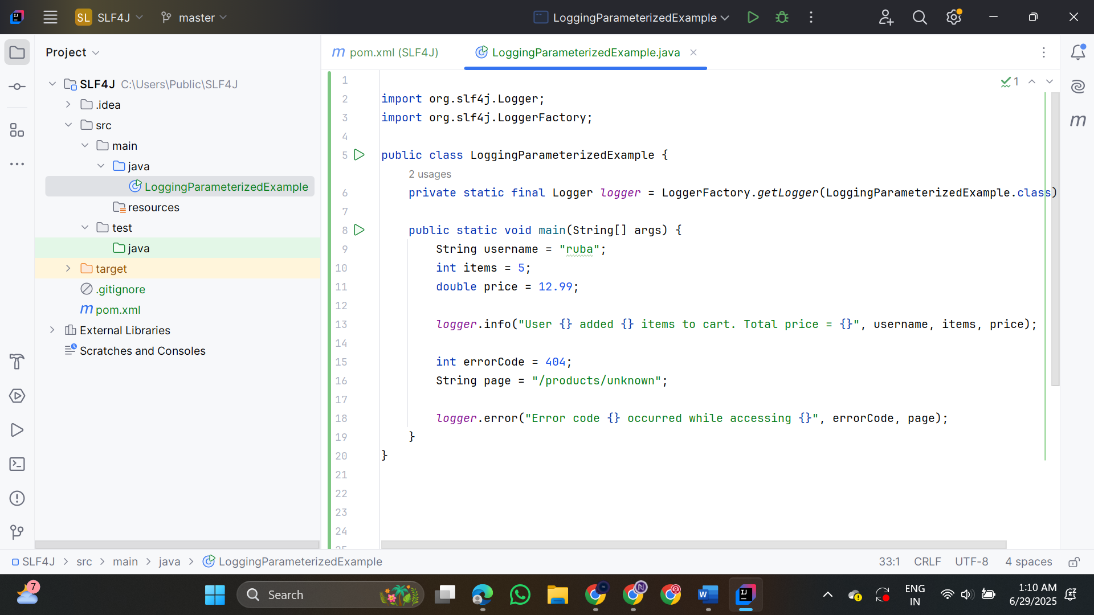

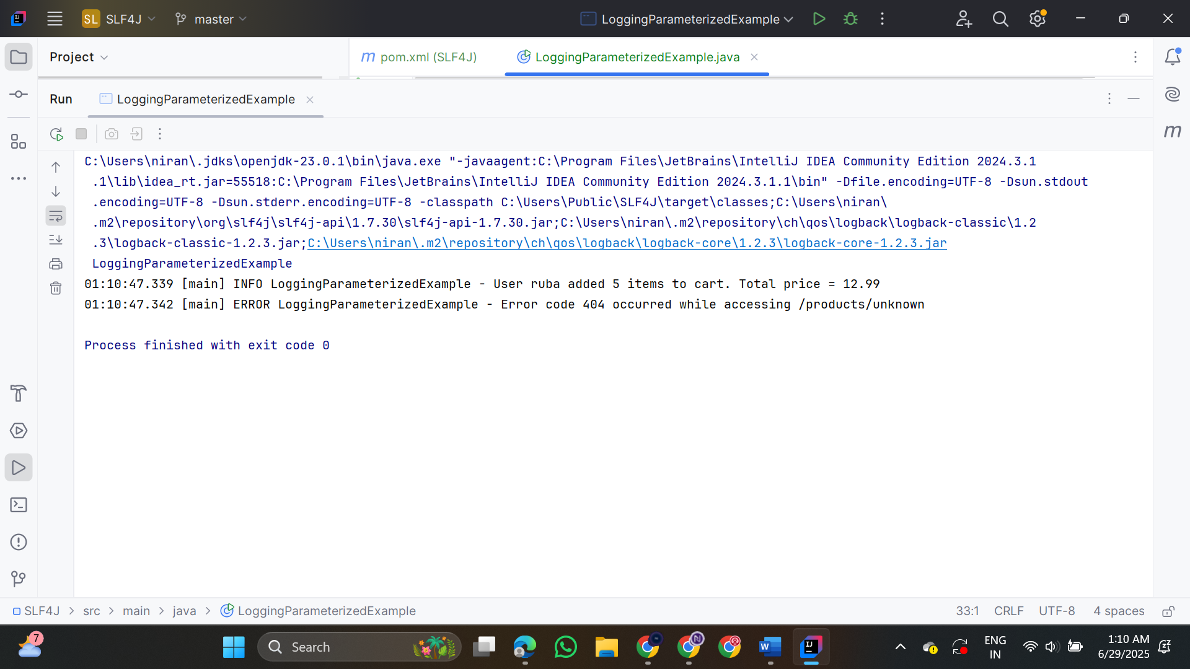

**3. Using Different Appenders**

**LoggingWithAppenders.java**

import org.slf4j.Logger;

import org.slf4j.LoggerFactory;

public class LoggingWithAppenders {

private static final Logger logger = LoggerFactory.getLogger(LoggingWithAppenders.class);

public static void main(String[] args) {

logger.info("This is an info message");

logger.debug("This is a debug message");

logger.warn("This is a warning message");

logger.error("This is an error message");

}

}

